LVM Session 1 Summary :

- Creating partition for any storage device we have to follow 3 steps:
- Partition
- Format / Create Filesystem(FS)
- Mount

- When we mount any partition to any folder then this mount is temporary in nature. It will again unmount as soon as we shutdown the operating system. When we reboot the system then we have to manually mount it to that partition. But data is permanent in that partition.

- If we have 2 storage devices such as a hard disk and that hard disk size is 20 GiB and 40 GiB respectively. And we have 50 GiB data. We want to store this data in one hard disk. But we can’t store this data in either the first hard disk or second hard disk because we don’t have 50 GiB space in one particular hard disk.

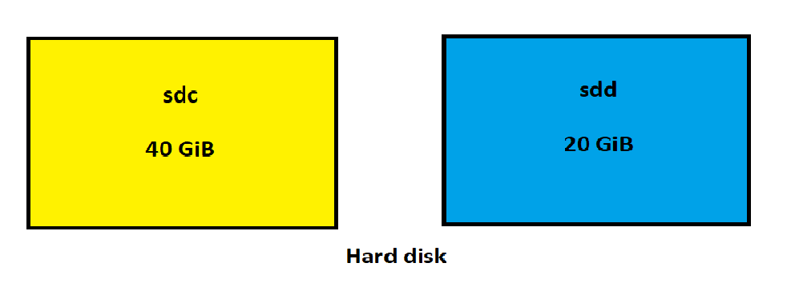
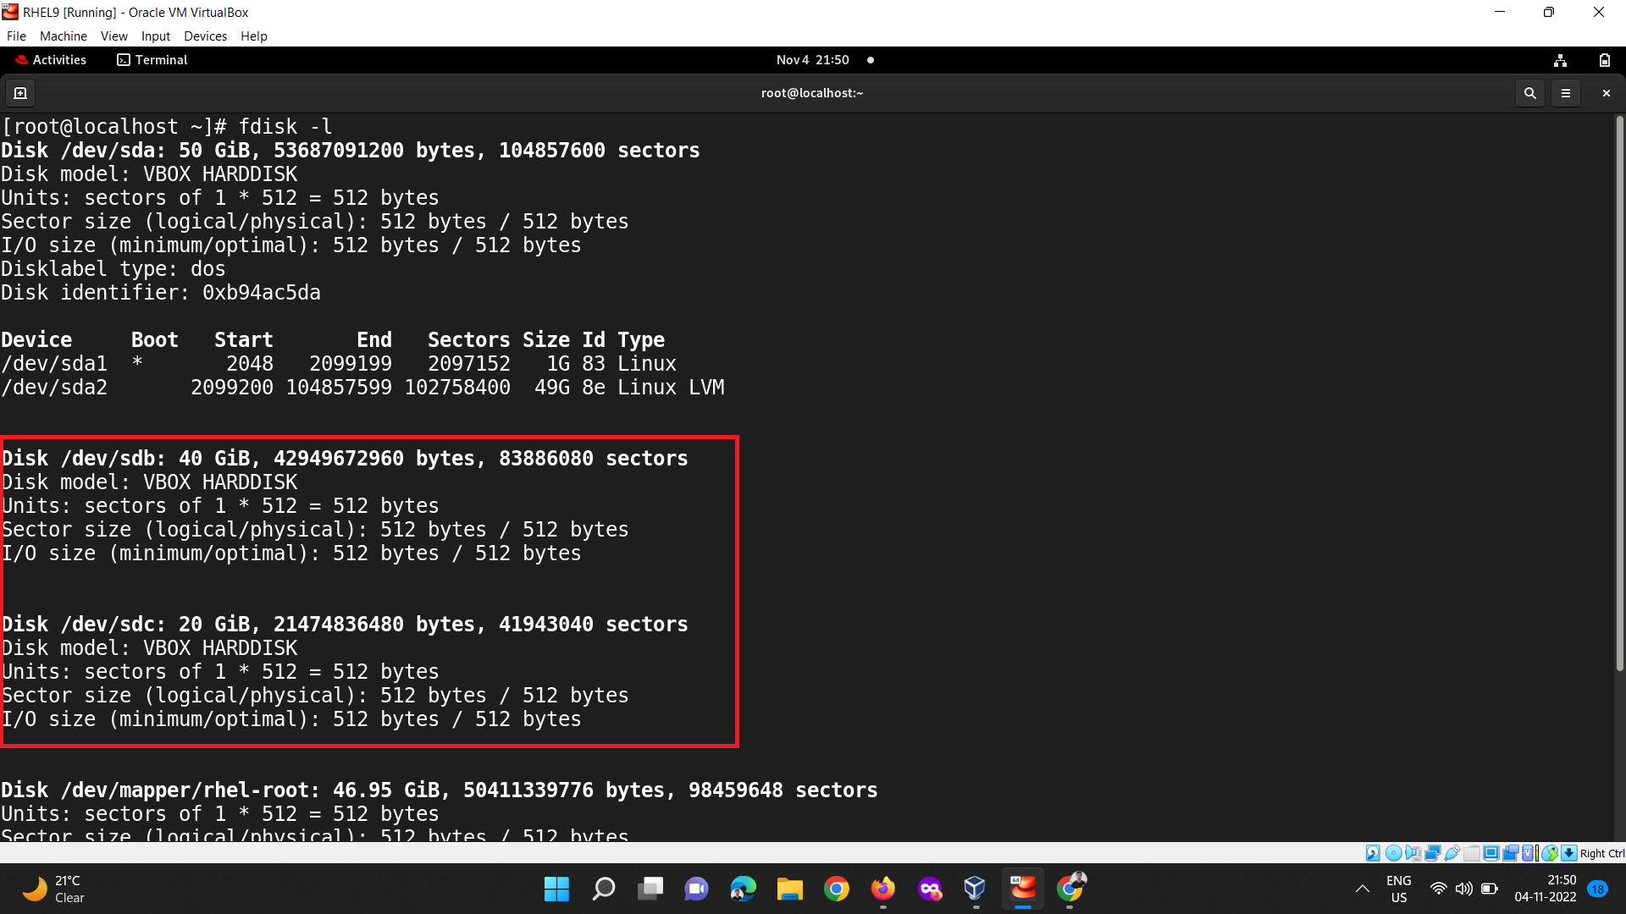

- Then what we can do is, we can combine both the devices (40 GiB + 20 GiB = 60 GiB) then we have a total 60 GiB space in one hard disk.

- Our operating system is sweet in nature. If we combine two or more hard disks then the operating system treats one hard disk. And this concept is known as LVM.

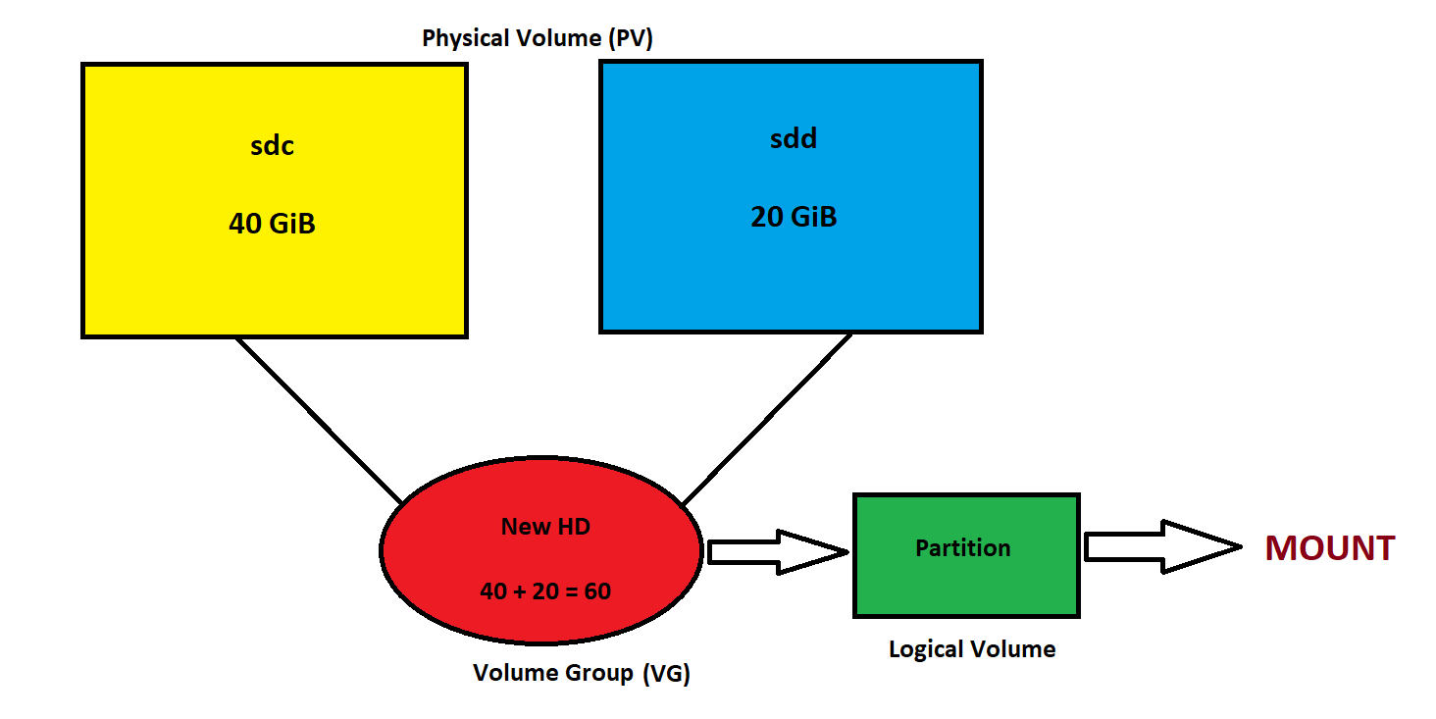
- According to above diagram we have to create first physical volume ie. PV from our hard disk devices. For this we used the pvcreate command.

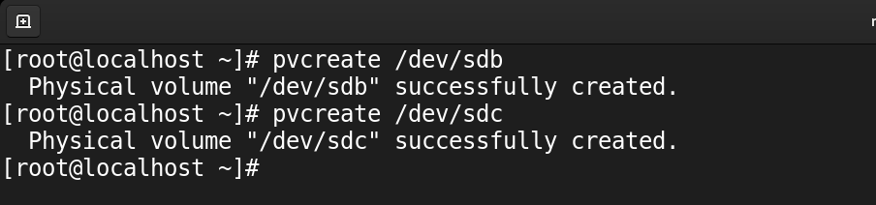

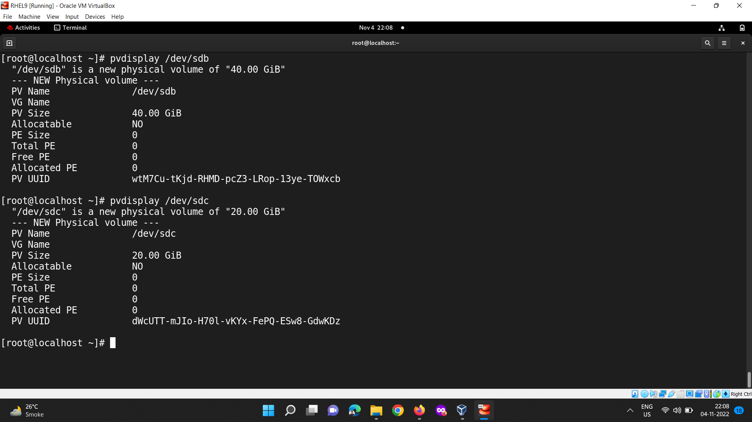

- Then we have to create volume group ie. VG from PV using vgcreate command.

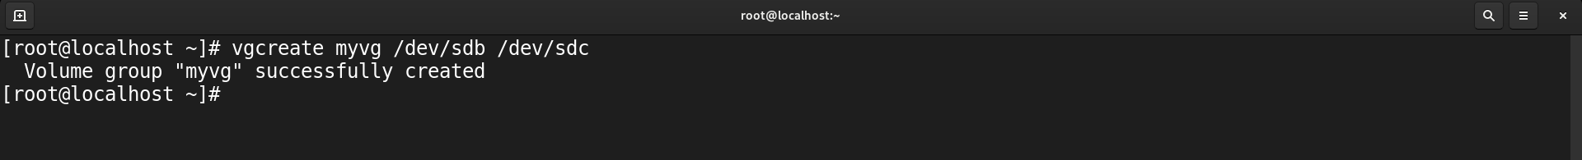
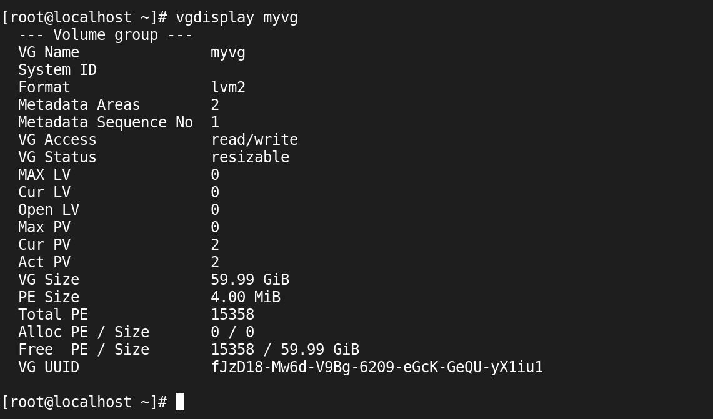

- As we already see we can create only 4 primary partitions or using extended partitions we can create 60 more partitions. But in LVM we can create as many as partitions.

- Now we have to create logical volume ie. LV of particular size from VG using lvcreate command.

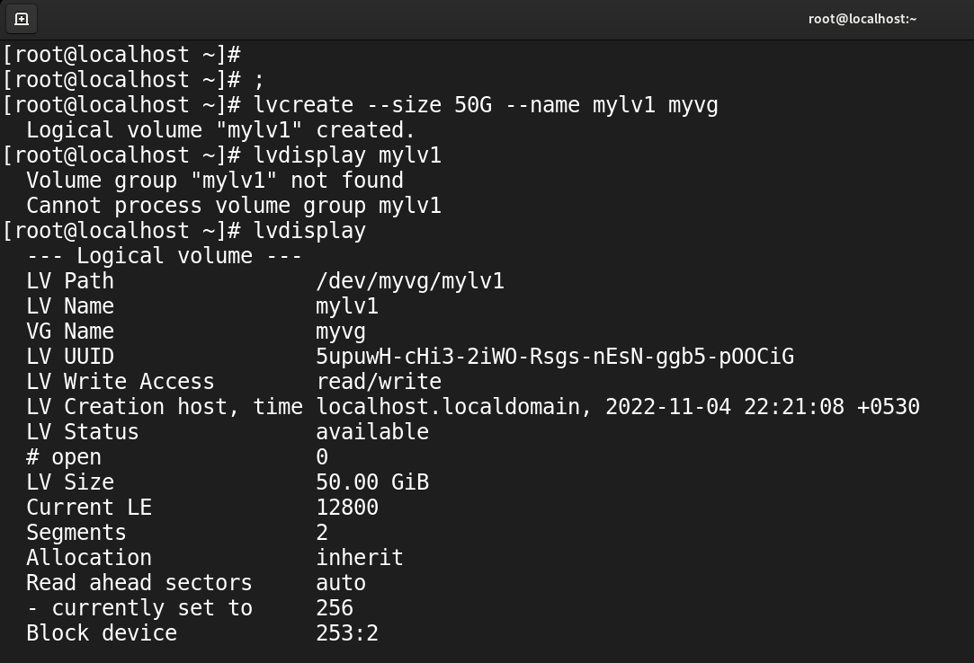

- After this we already know how to format and mount. So that command we need to perform.
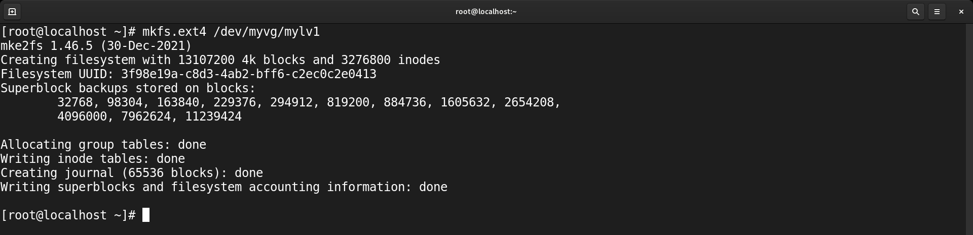
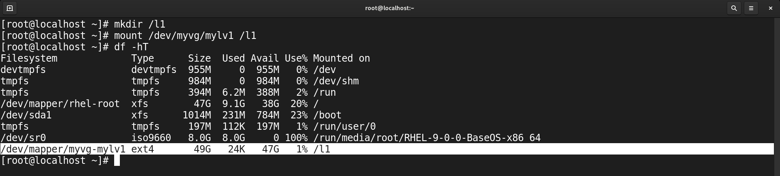

- Now we have a requirement that if we already have an LV of eg. 50 GiB and we want to increase the size of that LV without losing data. Then we have lvextend command.

- But the only condition is we can extend LV from only that particular VG from where we initially got storage.

- After extending we see space is added to that LV. But when we see the mount point using the df command then we only see the previous space size. Because we don’t create a filesystem for new storage. But if we create a filesystem for the whole LV then they will create a new file system and remove all previous data. But this we don’t want.

- For this we have a command which is resize2fs. First it will check till how much space we already create filesystem then it will create filesystem for those parts where we don’t create filesystem.

